
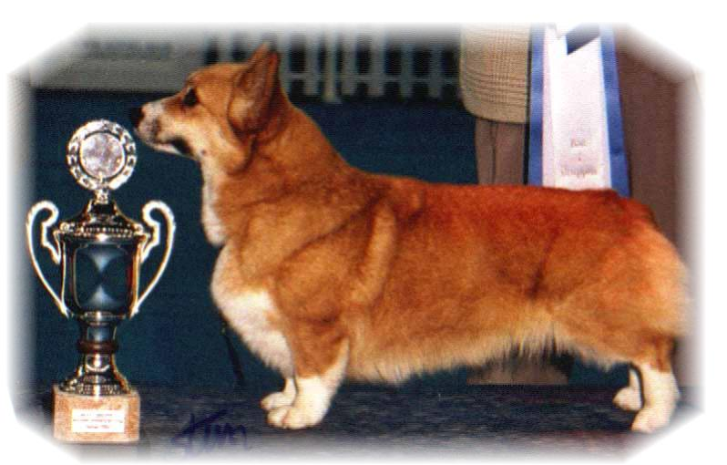

PARENTS |  | GRAND PARENTS |  | GREAT GRAND PARENTS |  | GREAT GREAT GRAND PARENTS
SIRE | WW-EW. CIB.RUS.IT  ANDVOL MERCURY  RKF2840284 | SIRE | RUS.LT CH  KINSALE STAR TREAT | SIRE | USA.UAR CH  LLANDIANS STORM CATCHER | SIRE | USA.CH ROMX ABERLEE STORM FORCE
 |  |  |  |  |  | DAM | POWDERMILL SWEET GOLD
 |  |  |  | DAM | UAR CH  KINSALE MIDNIGHT MAGIC | SIRE | UAR CH ABERLEE FOXYTALE OF HIGHLEIGH
 |  |  |  |  |  | DAM | HIGHLEIGH KIRI BEAR OF VON WINDECKE
SIRE | WW-EW. CIB.RUS.IT  ANDVOL MERCURY  RKF2840284 | DAM | EW.CIB.RUS.IRL.FIN CH  ANDVOL NINA RICCI | SIRE | RUS.SLO.POL CH  TWINAN GOLD SOVEREIGN | SIRE | HIGHWORTH PRESISION MADE
 |  |  |  |  |  | DAM | TWINAN THE STONEMAIDEN
 |  |  |  | DAM | ANFISA HAUS DANDO | SIRE | RUS CH ANDVOL ZOLOTY OSCAR
 |  |  |  |  |  | DAM | BARABAKA DJENESTRA
DAM | INT.NORD CH  SIGGEN’S QUEEN OF DIAMONDS | SIRE | USA GCH  TALLYRAND HALO CHASER | SIRE | USA.CH  ABERLEE BRANDSBY | SIRE | AUS.CH VLANDY SILVER PHANTOM
 |  |  |  |  |  | DAM | ABERLEE KIGA
 |  |  |  | DAM | TALLYRAND DEVOTED TO YOU | SIRE | USA.CH TALLYRAND ARCHANGEL MICHAEL
 |  |  |  |  |  | DAM | TALLYRAND CONSIER THE LILLIES
DAM | INT.NORD CH  SIGGEN’S QUEEN OF DIAMONDS | DAM | INT.NORD CH.NORDV11  SIGGEN’S HAZEL | SIRE | SE.EE.CH  CUUCHIN ASPENGLOW | SIRE | BELROYD DRAGONFLY
 |  |  |  |  |  | DAM | PEMLAND LADY OF NIGHT
 |  |  |  | DAM | INT.NORD.CH VWW 10  SIGGEN’S UPTOWN GIRL | SIRE | NORD.CH PEMLAND MOONLIGHT
 |  |  |  |  |  | DAM | INT.NORD.CH SIGGEN’S JESSIKA

PEDIGREE OF : | SIGGEN’S C-kull 16 |  | COLOUR AND MARKINGS :
DATE OF BIRTH : | 05.08.2016 |  | SEX :
Rita & Leif Herman Wilberg, Julie Wilberg Brandvik
Blåkollstubben 27, PB : 144
1921 Sørumsand, NORWAY
Tlf : +47 97027566, +47 90084320, +47 97763827
Email : leif.herman@wilberg.info rita@wilberg.info
www.kennelsiggen.com

