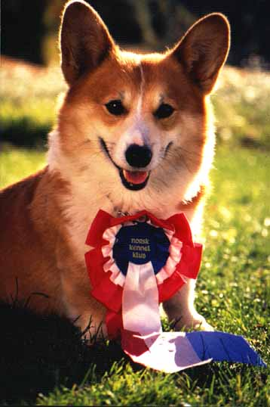
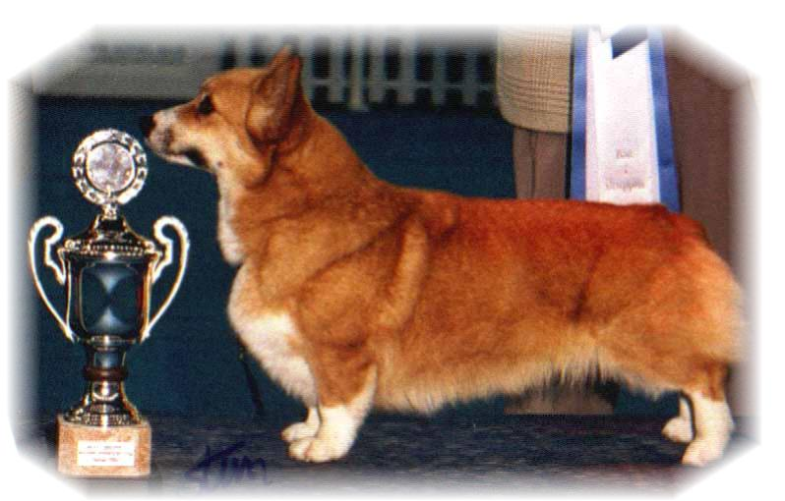

PARENTS |  | GRAND PARENTS |  | GREAT GRAND PARENTS |  | GREAT GREAT GRAND PARENTS
SIRE | SIGGEN’S ZEPPELIN  NO49975/15 | SIRE | WW09.US.INT.EE.SE.SK. CH  NEBRIOWA COLE HAAN | SIRE | US. CH  FERGWYN NEW VOYAGER | SIRE | FERGWEN CAPTAIN FANTASY
 |  |  |  |  |  | DAM | FERGWEN CHANCE ENCOUNTER
 |  |  |  | DAM | US.CH  NEBRIOWA HELLO GOOD LOOKING | SIRE | ROMX.US.CH HUMMINGBIRD VALEDICTORIAN
 |  |  |  |  |  | DAM | US.CH NEBRIOWA CHINA DOVE
SIRE | SIGGEN’S ZEPPELIN  NO49975/15 | DAM | INT.NORD.FI.PH.CH  SIGGEN’S SWEET SENSATION | SIRE | ROM.US.GRAND.CH  TALLYRAND HALO CHASER | SIRE | US.CH ABERLEE BRANSBY
 |  |  |  |  |  | DAM | TALLYRAND DEVOTED TO YOU
 |  |  |  | DAM | INT.NORD.CH.NORDV-10  SIGGEN’S HAZEL | SIRE | INT.AUS.SE.EE.CH CUUCHIN ASPENGLOW
 |  |  |  |  |  | DAM | WW10.WWV11.EUW06. INT.NORD.CH MULTI VINNER SIGGEN’S UPTOWN GIRL
DAM | GB.INT.NORD.FI.HR.CH  JWW13,SEV13,14,DKV13,14,  NV14,NORDV14  SIGGEN’S QUEEN OF SPADES NO45957/12 | SIRE | GB.INT.MULTI.CH.WW08,  EUW11  ANDVOL YA TVOY KUMIR | SIRE | INT.RUS.MOL.UKR.CH  ERMYN CRANBERRY FROST | SIRE | GB.CH ERMYN WING AND A PRAYER
 |  |  |  |  |  | DAM | JANJINKS NOONDAY STAR AT ERMYN
 |  |  |  | DAM | INT.RUS.CH  ANDVOL KOROLEVA MARGO | SIRE | RUS.CH ANDVOL ZOLOTOY OSCAR
 |  |  |  |  |  | DAM | ANDVOL EMILI
DAM |  | DAM | INT.NORD.CH NORDV-10  SIGGEN’S HAZEL | SIRE | INT.AUS.SE.EE.CH  CUUCHIN ASPENGLOW | SIRE | AUS.CH CUUCHIN LOTZA PIZAZZ
 |  |  |  |  |  | DAM | CUUCHIN GOLD SEQUINS
 |  |  |  | DAM | WW-10,WWV-11. INT. NORD N.S.DK.SF.NV-04.SV-04,05. EUV-06  SIGGEN’S UPTOWN GIRL | SIRE | NORD.CH PWMLAND MOONLIGHT
 |  |  |  |  |  | DAM | INT.NORD.CH SIGGEN’S JESSIKA

PEDIGREE OF : | Siggen’s D-kull |  | COLOUR AND MARKINGS :
DATE OF BIRTH : | 04.11.2016 |  | SEX :
Rita & Leif Herman Wilberg,Julie W.Brandvik
Blåkollstubben 27, PB : 144
1921 Sørumsand, NORWAY
Tlf : +47 97027566, +47 90084320, +47 97763827
Email : leif.herman@wilberg.info rita@wilberg.info julie_wilberg@hotmail.com
www.kennelsiggen.com

